**Data definitions for Under Keel Clearance (UKC)**

**Introduction**

UKC is a very important aspect of discussions related to maintenance of deep water routes, fairways, basins and berths. Such maintenance is very costly and a few centimeters less depth already result in millions of savings. Same applies to maximum draught: one centimeter extra draught for a VLCC or 12.000 TEU vessel already result in 150 Tons more cargo, equivalent to 50.000 to 180.000 US$, depending on type of cargo and market conditions.

Ports have their own UKC policies, which can be different in the approach versus e.g. at berth.

UKC policy is also part of the charter party, the contract to hire a ship between owner and charterer. When a Captain is confronted with an UKC policy after boarding of the pilot, it may result in last minute discussions with headquarters whether the ship will breach the charter party clauses or not, a time when the bridge team should be focused on the safe port passage. Especially in deep water routes it is important for the bridge team to understand how much allowance is available for e.g. ship movement. For design, maintenance and navigation discussions it is beneficial to have a clear understanding about the data definitions related to UKC.

**Current publications related to UKC**

PIANC - report no.121-214

PIANC stands for Permanent International Association of Navigation Congresses. PIANC has worked on a standard for design of vertical channel dimensions in her report 121-214, chapter 2 together with IAPH, IALA and IMPA.

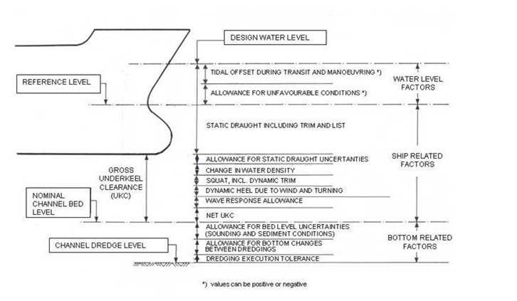

Image of PIANC Report no. 121-2014

IHO WG - S-129  
IHO stands for International Hydrographic Organization. Within IHO one work group has worked on a standard to exchange UKC data to the ship’s ECDIS and the pilot’s PPU to allow both bridge team and pilot to understand when the ship will breach the UKC policy. It does not work on the data definitions of the UKC policy.

UKHO - NP100, Mariners Handbook

UKHO stands for United Kingdom Hydrographic Office. UKHO publishes the Mariners Handbook, Nautical Publication (NP) 100, which is sitting on the bridge of most SOLAS vessels. In the glossary of this publication many definitions related to navigation are published.

In alphabetical order:

Bottom, nature of

The feature of the bottom including the material of which it is composed and its physical characteristics (IHO S-57)

Format: Fixed format text according to IHO S-4 and IHO S-57 values. E.g. Sand, Mud, Clay, Silt, Stones, Gravel, Pebbles, Cobbles, Rock, Boulder, Coral

Draught

The vertical distance from the bottom of the keel to the waterline (NP100)

Units: decimal metres to a defined water density measured in kg/m3

Fresh Water Allowance (FWA)

The change in draught of a vessel due to the difference between salt and fresh water (NP100)

Units: decimal metres

Height of tide

The vertical distance from the chart datum to the level of the water at a particular time (IHO S-32)

Units: decimal metres with reference to a specific Sounding Datum

Maintained depth

The Depth at which a channel is kept by human influence, usually by dredging (NP100)

Units: decimal metres with reference to a specific Sounding Datum

Observed depth

The vertical distance from the sea surface to the sea floor, at any state of the tide

Overdredge

An additional depth margin provided by a dredging operation to ensure that the depth at a specific location is never less than the pre-determined maintained depth over the interval between programmed dredging operations (NP100)

Units: decimal metres

Pitch

Angular motion of a ship in the fore-and-aft plane

Roll

The angular motion of a ship in the athwartship plane

Sea waves

Almost all waves at sea are caused by wind, although some may be caused by other forces of nature such as volcanic explosions or earthquakes or even icebergs calving.

Sounding

Measured or charted depth of water or the measurement of such a depth (IHO S-32)

Units: decimal metres with reference to a specific Sounding Datum

Squat

The decrease in under-keel clearance which occurs when a vessel is making way, or stationary in moving water. An element of shallow water effect, it is caused by increased velocity of water flow under a hull an the consequent reduction in pressure

Swell

Swell is the wave motion caused by a meteorological disturbance that persists after the disturbance has died or moved away

Under Keel Clearance (UKC)

The difference between the draught of a vessel and the available depth of water. This is usually the distance between the lowest point of the ship’s hull, normally some point on the keel, and the sea bed but consideration must also be given to possible obstructions on the sea bed (IHO S-32)

Units: a defined value in decimal metres or a percentage of draught and/or beam

Under Keel Clearance (UKC) policy

A restriction imposed by an authority on a vessel to ensure the depth below the keel meets an acceptable (usually minimum) single or range of values. May apply to a specific area, type of vessel on arrival, alongside or departure

Units: decimal metres or a percentage of draught and/or beam

Water Density

The minimum water density value within a particular area. (NP100)

Units: kg/m3

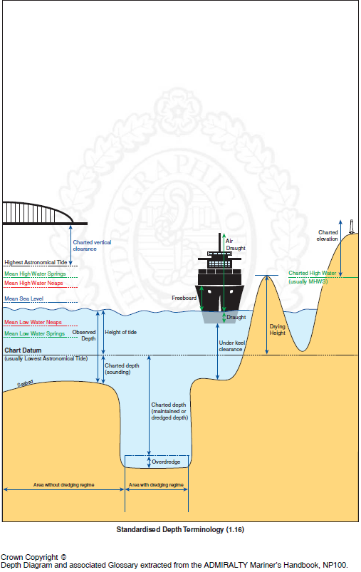

Image Mariners Handbook, NP100

ITPCO – Port Information Manual

ITPCO stands for International Taskforce Port Call Optimization, where shipping and ports are working together to promote port call optimization through improving quality and availability of master and event data.

One of their publications is the Port Information Manual, aiming to bring existing standards together and to address missing standards or where standards could be improved.

In close collaboration with UKHO NP100 team and matter experts of ports and shipping this publication publishes existing data definitions or proposes fine tuning of existing definitions to meet the needs of the maritime industry.

During discussions regarding UKC the existing definitions of PIANC, IHO and those already used in the shipping industry were brought together.

A template which is often used in the shipping industry is:

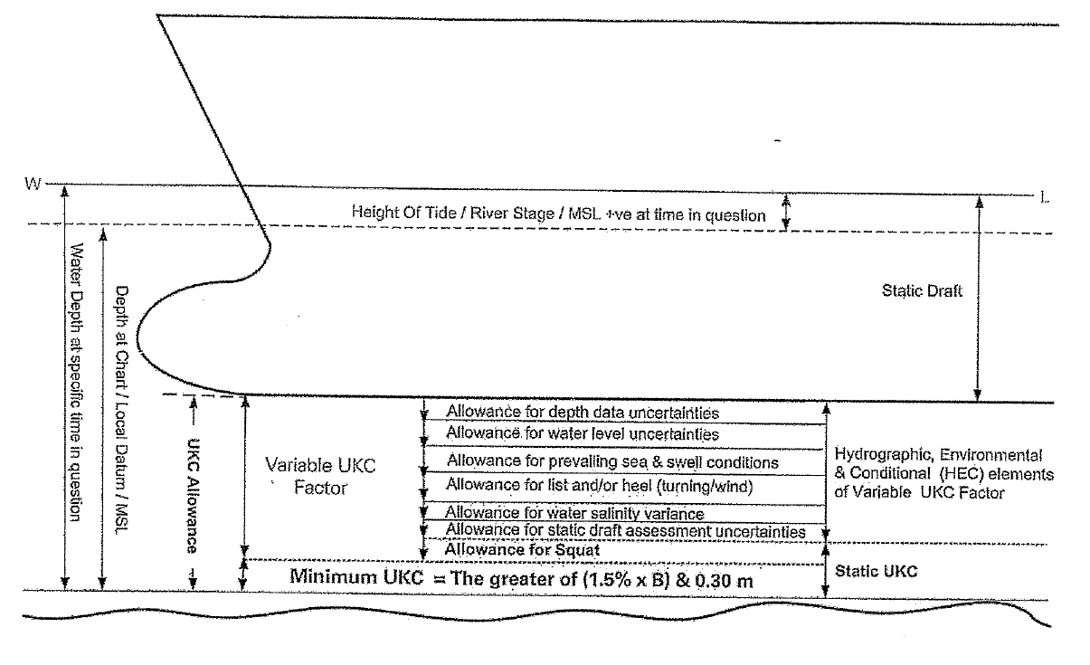

Image of tanker shipping

Proposal

A proposal to bring existing definitions of PIANC, IHO / NP100 and the maritime industry together:

|  |  |  |  |  |  |
| --- | --- | --- | --- | --- | --- |
| PIANC | | Industry | Proposal using NP100 nomenclature | | |
| Ship related factors | Static draught uncertainties | Allowance for static draft assessment uncertainties | Allowance for draft assessment accuracy | Allowance for ship draught accuracy | Gross UKC |
| Water density uncertainties | Allowance for water salinity variance | Allowance for water density accuracy |
| Allowance for list |
| Squat, including dynamic trim | Allowance for squat | Allowance for squat | Allowance for ship movement |
| Dynamic heel due to wind and turning | Allowance for list and/heel (turning and wind) | Allowance for heel |
| Wave response | Allowance for prevailing sea and swell conditions | Allowance for heave, pitch and roll |
| Water level factors | Unfavorable conditions | Allowance for water level uncertainties | Allowance for tidal height accuracy | Allowance for observed depth accuracy |
| Tidal offset during transit and maneuvering |  | Allowance for tidal height during transit and maneuvering |
| Bottom related factors | Bed level uncertainties | Allowance for depth data uncertainties | Allowance for accuracy of soundings or dredging execution |
| Bottom changes between dredging’s |  | Allowance for siltation of soundings |
| Dredging execution tolerance |  |  |
|  | Net UKC | Minimum UKC | Net UKC | Net UKC |

Missing definitions

List

*Suggestion: The inclination of a vessel to either port or starboard in an equilibrium situation of a vessel not caused by outside factors, but by inside factors such as e.g. uneven loading or flooding*

Heel

*Suggestion: Temporarily inclination of a vessel caused by outside factors such as winds or during a ships turn*

Heave

*Suggestion: The up and down movement of a vessel caused by outside factors such as sea or swell*

Net UKC

*Suggestion: Is the UKC minus all allowances for observed depth accuracy, ship draught and ship movement*

Gross UKC

*Suggestion: Is the UKC including all allowances for observed depth accuracy, ship draught and ship movement*

Definitions that could be improved / be fine tuned (changes in italics)

*Static* draught

The *maximum* vertical distance from the bottom of the keel to the waterline *in static condition* (NP100)

Units: decimal metres to a defined water density measured in kg/m3

Roll

The *dynamic* angular motion of a *ship from side to side* in the athwartship plane *caused by waves*

Squat

The decrease in under-keel clearance which occurs when a vessel is making way, or stationary in moving water. An element of shallow water effect, it is caused by increased velocity of water flow under a hull and the consequent reduction in pressure

*This is effect is also present in non-shallow water*

Sea waves

Almost all waves at sea are caused by wind, although some may be caused by other forces of nature such as volcanic explosions or earthquakes or even icebergs calving. *Is this definition aligned with WMO?*

Swell

Swell is the wave motion caused by a meteorological disturbance that persists after the disturbance has died or moved away. *Is this definition aligned with WMO?*

Contacts

PIANC: Wim Hoebee, Pieter Nordbeck, Egbert van de Wal, IHMA

IHO WG S129: Nick Lemon

UKHO: Neil Salter, Jonathan Lewis

ITPCO: Ben van Scherpenzeel